Data Structures
Dynamic Vs Static
Dynamic:
Pros
- More efficient memory usage.
- Can be expanded as needed.
Cons
- Possible for structure to overflow if its limit is exceeded.
- Harder to program as need to keep track of its size and data item locations.

Static:
Pros:
- Memory allocation is fixed so no problem with adding and removing data.
- Easier to program as fewer checks need to be made.
Cons:
- Can be inefficient as too much memory for the data could be allocated.

Linked Lists
- The size doesn't have to be stated as it's a dynamic data structure
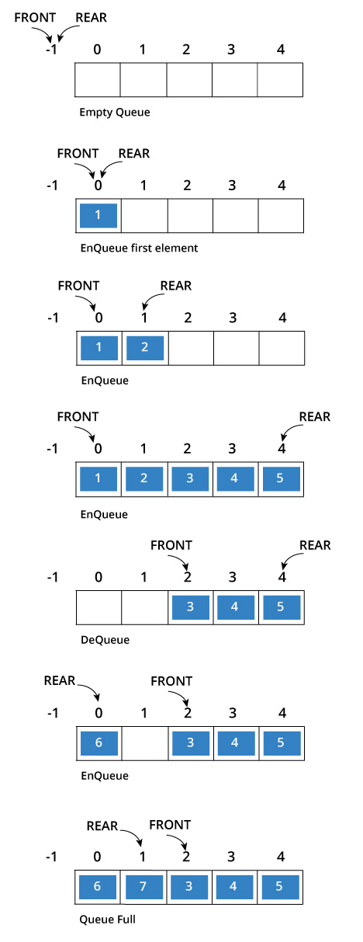
- Each item in a linked list contains the actual data and a pointer to the location of the next bit of data
- Each data item can have multiple pointers to allow quick sorting of the data in multiple ways

Queue (First in first out FIFO)
- List or an array can only be added to at one end and have values removed at the other end
- It's a serial structure
- Need a head and a tail pointer
- Operations:
- Add/Push - Add an item to the back of a queue
- Remove/Pop - Remove the item at the front of the queue
- Front - Identifies the value at the front of the queue
- If you pop off a value on the queue, that memory address in then wasted

Circular queues (Circular buffers)
- Add data values after the initial end pointer until there's no more space, then it adds stuff to the start of the queue
- If you try to add another data item there should be an error if the start pointer is equal to the end pointer +1

Stacks (Last in first out LIFO)
- Last in first out data structure, so if you just add "C", then if you read (poped) the stack it would return "C"
- Operations:
- Push - Add an item to the top of the stack
- Pop - Removes an item from the top of the stack
- Top - Identifies the item at the top of the stack but doesn't remove it
- Can get a stack overflow if you try to push too many data values
- Can get a stack underflow if you pop too many values

